/\*Ashok PowerBI Transformation lab 9.4.19\*/

* Submit screen shots of PowerBI DeskTop opening page, ClientSince in descending order with no

timestamp, and the 3 additional columns created

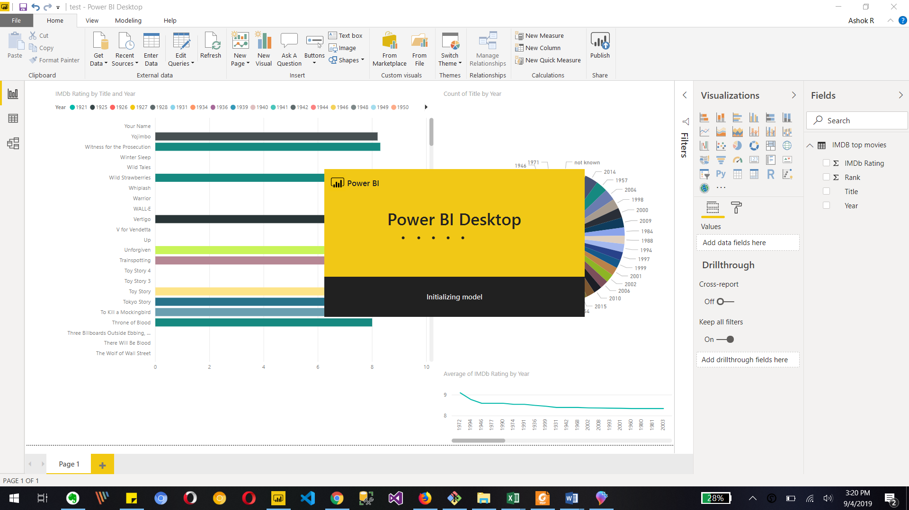

Starting power bi

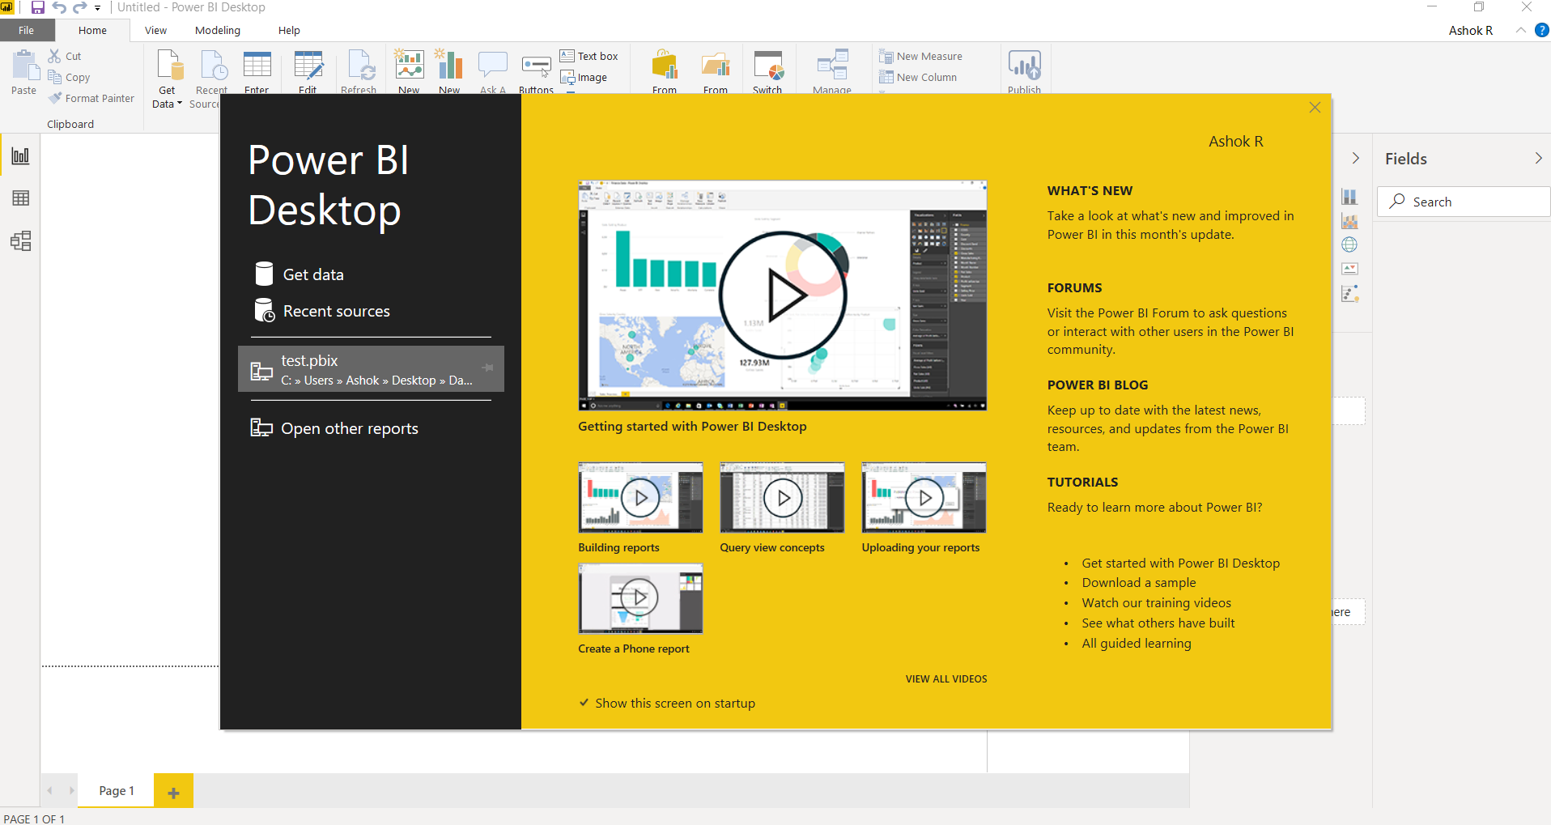

Power bi Start page to select data

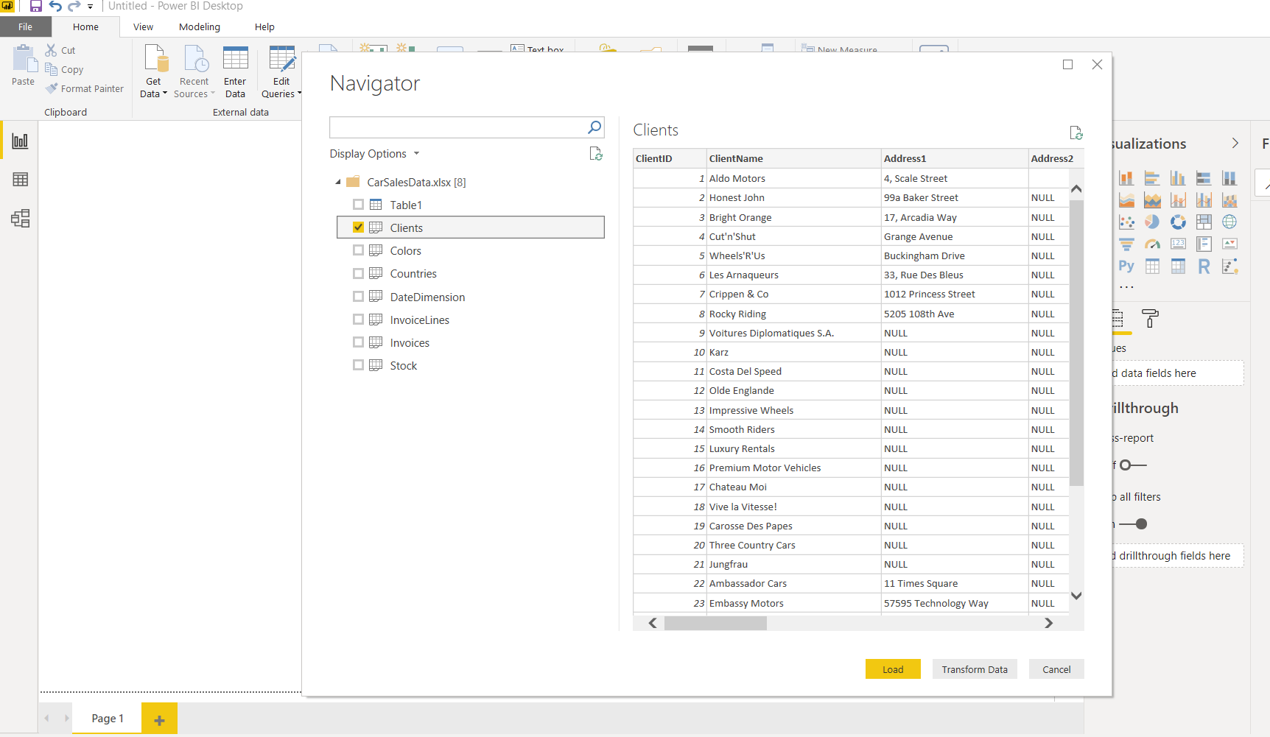

Loading excel file to select clients sheet

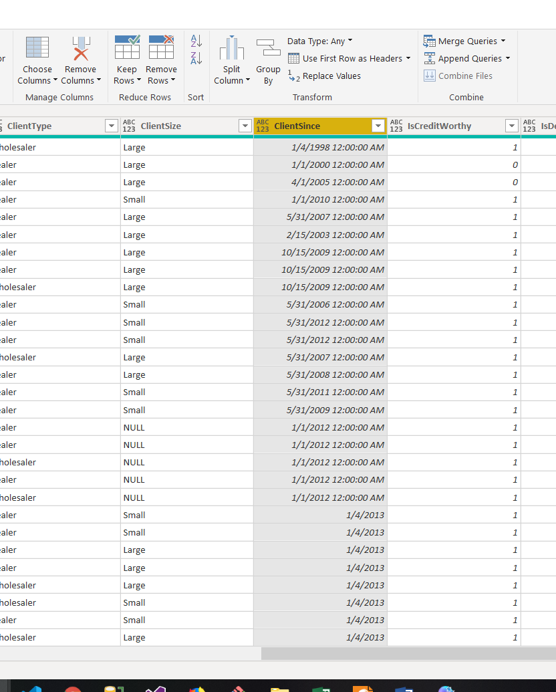

Showing ClientSince column from excel sheet in power bi query editor

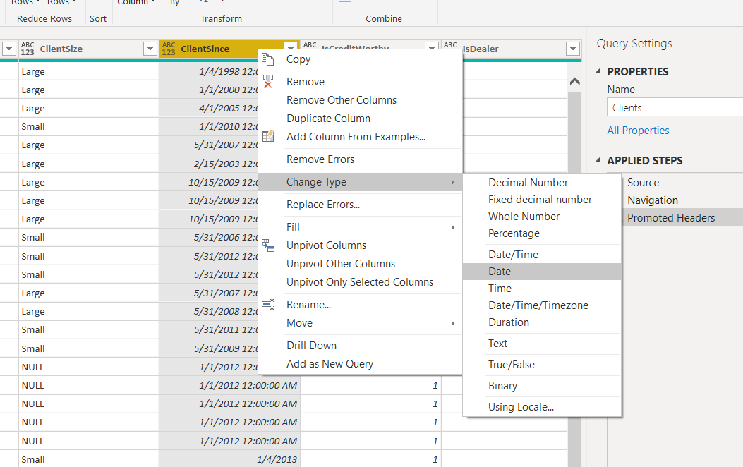

Changing the datatype for client since column to date from timestamp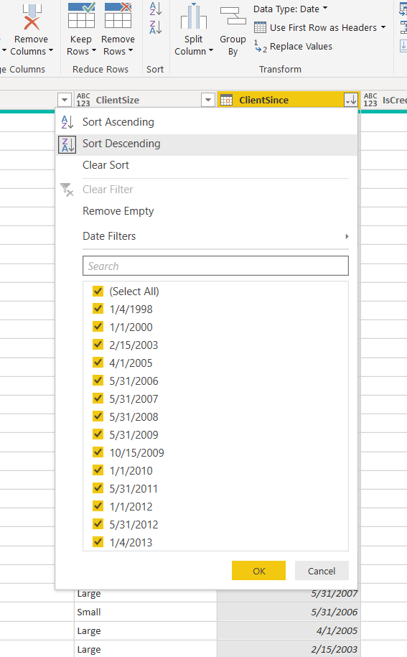

Sorting column data in descending order

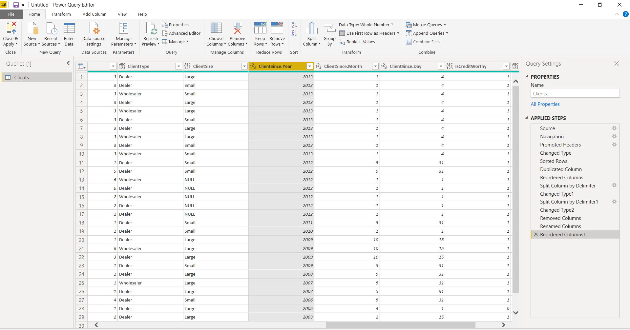

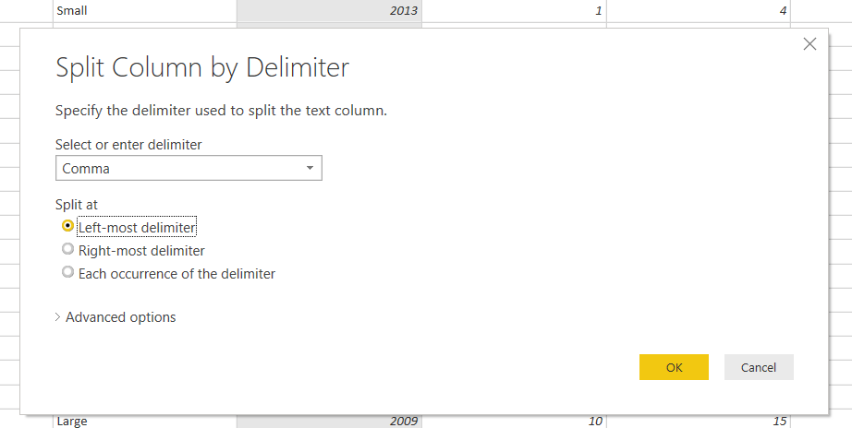

We use split column data to create new column for month day and year with using delimiter ‘/’ as we can see the result in above image